**Lab : 07**

**Name: Abhinav Rajput**

**PRN: 18070123005**

**Batch:EA1(G1)**

**Aim:**

Client server program for echo.

**Source code:**

**Server side**

import socket  
  
def server_sock():  
 host = socket.gethostname() *# to get the host name* port = 8888 *# initiating port no. above 1024* print(**"Creating socket.... "**)  
 server_socket = socket.socket() *# Create socket* print(**"Socket created, now binding with host - {} and port - {}"**.format(host, port))  
 server_socket.bind((host, port)) *# Binding host address with port address* print(**"Socket Bound"**)  
  
 server_socket.listen(1) *# Server listening to one client* print(**"Listening.... "**)  
 conn, address = server_socket.accept() *# accepting new connection* print(**"Connection from: "** + str(address))  
 while True:  
 *# receive data stream. It won;t accept data packet greater than 1024 bytes.* data = conn.recv(1024).decode()  
 if data == **'bye'**:  
 print(**"From connected user: "** + str(data))  
 break  
 print(**"From connected user: "** + str(data))  
  
 data = **"Echo confirmed, thank you for Connecting!"** conn.send(data.encode()) *# Send data to the client* print(**"Closing Connection... "**)  
 conn.close() *# close the connection*if __name__ == **"__main__"**:  
 server_sock()

**Client side:**

import socket  
  
  
def client_sock():  
 host = socket.gethostname() *# As both code are running on same pc* port = 8888 *# Socket server port number* print(**"Creating socket.... "**)  
 client_socket = socket.socket() *# Instantiate* print(**"Socket created, now binding with host - {} and port - {}"**.format(host, port))  
 client_socket.connect((host, port)) *# Connect to the server* print(**"Socket Bound"**)  
  
 message = input(**"Enter echo message to the send (under 1024 bytes): "**)  
  
 while message.lower().strip() != **'bye'**: *# termination check* print(**"Sending Message.... "**)  
 client_socket.send(message.encode()) *# send message* data = client_socket.recv(1024).decode() *# receive response* print(**"Received from server: {}"**.format(data)) *# Show in terminal* message = input(**"Enter 'bye' to end or another message: "**)  
 if message == **'bye'**:  
 client_socket.send(message.encode())  
  
 print(**"Closing Connection... "**)  
 client_socket.close() *# close the connection*if __name__ == **"__main__"**:  
 client_sock()

**SS of Server window:**

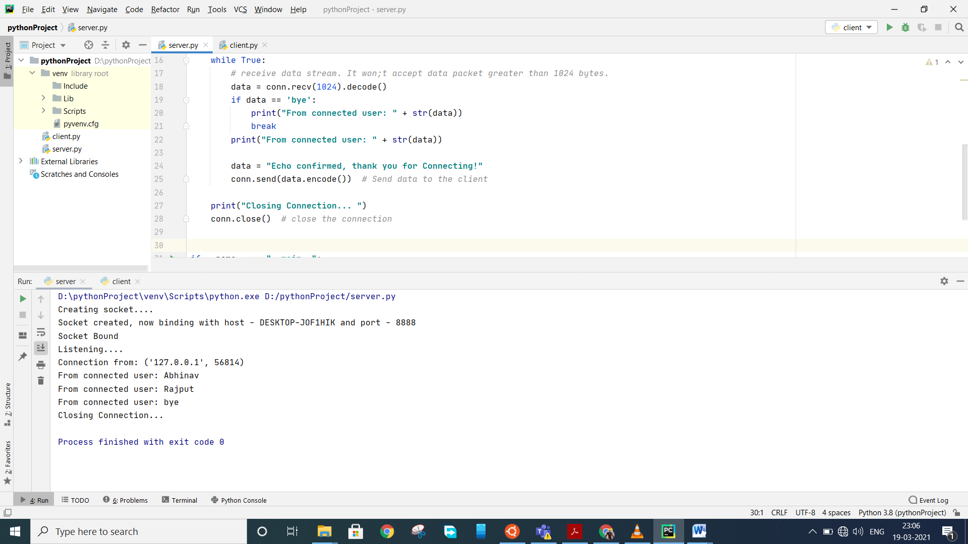

**SS of Client side:**

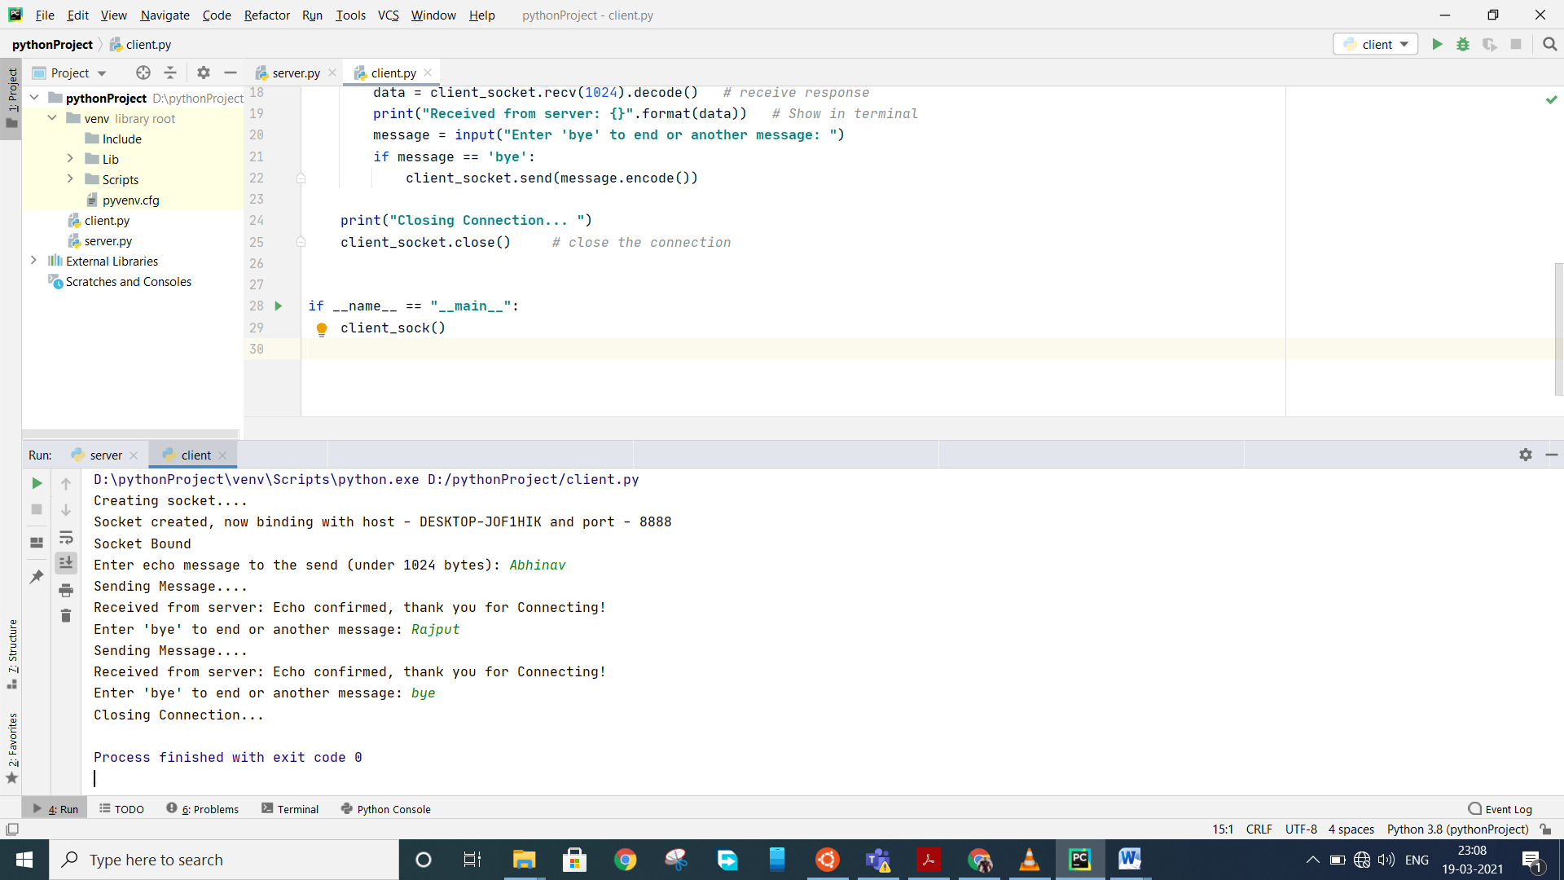

**Conclusion:**

From above lab work, I learnt to write socket program and also analyzed how client and server process take place in real world.